Dalworth Restoration Web Site

Open Questions
Questions:
- For insurance adjuster business partner, what extra information do we want to show. ( reading, how many monitoring visits, graph of drawing, date of completion of the flood, paperwork scans?)
- DO we need to have the following functionality?
  - Customer calls directly to Dalworth
  - Customer specifies Joe from Start Farm as insurance
  - Dalworth calls Joe and talks about insurance and send him email with the login to the system where adjuster can monitor progress of the job.
  - Need separate screen for insurance adjuster.
  - Who relates project to insurance adjustors?

TOD0
- Add grid that shows all the projects that are created that don’t have any business partner or account manager assigned.
- On list of leads, show account manager in the grid
- On create lead, allow to either start with customer or business partner
- Account Manager view projects on a website

Users
- Customer – end customer, interested in service such as Rug Pickup, Carpet Cleaning, and Flood and see status of his jobs. Customer is shared between Dalworth Restoration and Carpet Cleaning. Customer may be Residential or Business Customer
- Business Partner – entity that is interested to do business with Dalworth. Interested in submitting leads , see status of the projects created as result of leads, notified on project status changes
  - Regular Business Partner – business partner who is not Franchisee or Insurance adjustor. Typically outside service company (Molly Maids)
  - Insurance Adjustors Business Partner - Review his client’s flood project status regardless if project was generated as a result of his lead or not.
    - Status of the project
    - Completion date
    - Closed Amount
    - Notes
    - Paperwork
    - Number of monitoring completed
    - Latest readings
    - Equipment qty on customer site
    - What else?
  - Dalworth Franchisee – If oriental rug project was completed for his exclusive customer without his lead, Dalworth Franchisee receives residual commission.
- Account Manager – manages business relationships with Business Partners and Business Customers. Creates leads, view status of leads, sets up ERP with Business Customers and Contracts with Business Partners
  - Primary Account Manager – account manager that can reassign business partners from one account manager to another.
- Company Owner – sees reports such as leads, jobs completed, jobs created as result of Account Manager activity, Jobs created based on Business Partner activity, status of Business Customers projects
- Dispatcher – reviews leads, creates projects
- Bookkeeper – posts payment transactions to each business partner at the end of the month, posts adjustments to Business Partner
- Administrator – sets up configuration information, maintenance of the site

Glossary
- Contract – agreement between Dalworth and Business Partner on commissions owed for each project type. Contract may be of type percent (percent of closed amount) or flat fee (fixed payment for each closed project type)
- ERP – Emergency response contract. Contract between Dalworth and Business Customer on preferential service terms for Flood.
- Lead – summary of intent to create a project. Leads are generated by Customers or Business Partners and can be recorded by Account Manager on behalf of customer or business partner.

Phase 1 delivery scenario
- Implement web site from ordinal BP and franchisee
  - Users can view their leads and transactions only
  - Simplified create lead for BP. The form will notify dispatcher about the lead.
  - Franchisee will not see related projects.
  - Residual commissions could be found on transactions screen
- Do not implement account manager’s web site
- List on business partners will be entered into DB manually
- All the information about new leads will be given to the dispatcher (by phone, email etc...)
- Dispatcher will not see incoming lead. No lead conversion into the real project
- Dispatcher should be able to specify lead source on visit creation (ordinal BP or franchisee). Leads will be automatically generated
- If dispatch cannot find specific BP he’ll enter his name as text. We’ll have to review such leads and create BP manually in DB
- There will be no BP to AM association for now
- Contracts will be configured manually in the db.
- When project is closed, commission s will be generated automatically
- IF lead never converted to job, Dispatcher will have to send emal to bp no notify him about it
  - Is it OK on phase 1 for BP not to see leads in status submitted or cancelled?.
- Will provide Excel monthly report for each bp with transactions and payments.
- Excel Report for leads

Business description
The goal of the system is to enable Account Managers establish business relationships with Business Partners and Business Customers.

Relationships with Business Partners
When relationship is established with Business Partner, business partner is expected to submit leads to Dalworth and be compensated when the leads are converted to projects. When Business Partner is signed into the program, Account Manager defines contract between Dalworth and Business Partner. Contract defines commission due to the Business Partner after lead is converted to project and Dalworth completed the job.
If business partner has a lead, he may call his Account Manager or go to the web site and create a lead. Business Partner is notified on the status changes of his leads via emails or by logging in into web site and see status of his leads.
After project is completed, transactions are generated for this business partner on the amount of the commission owned. Business Partner can login to the web site and check his balance with Dalworth or call Account Manager and ask him about his commission amount.
All business partners only receive commission if project was created as a result of the lead. It is possible for different business partners to refer different projects for the same customer to Dalworth. Each business partner will receive commission only for the lead they submitted after the project completes. Business partners only can view customers that they have submitted to Dalworth as part of the lead.
The following exception is made for Dalworth Franchisees. If Dalworth completed oriental rug project for exclusive franchisee, and Lead was not generated by Exclusive Franchisee, then Exclusive Franchisee will receive residual commission for this job from Dalworth.

Relationships with Customers.
Dalworth wants to be able to assign Account Manager to large commercial customers. Account Manager solicits large commercial customers by different marketing methods and may sign ERP (Emergency Response Contract) with the customer. ERP specifies preferential pricing, treatment with the customer. IF customer needs job done, it may login to its web site, call Account Manager or call Dalworth directly and order a service. Dalworth wants to be able to recognize that job was created as a result of Account Manager Activity regardless if customer contacted Dispatcher, Business Partner or Account Manger. Every commercial customer that has called for service that does not have Account Manager assigned must be reviewed by Company Owner to make the following decisions:
- Should this customer be assigned account manager
- If this customer already has account manager assigned but was not recognized (duplicate) during order entry
During order entry, if customer already assigned Account Manger, dispatcher should know that this customer has Account Manager, if this customer has ERP contract and if this customer also has Business Partner assigned.

Leads, Projects and Debit Transactions management
- Lead can be created by Customer (from web site), Business Partner and Account Manager.
- If business partner doesn’t have processed lead for particular customer, he should specify draft customer information.
- Once lead created, it will be visible to dispatcher and to account manager. Account manager that is assigned to this Business Partner will see this lead with default filter settings. Other account managers will have to modify filter settings to see this lead.
- Account manager never set real customer to the lead if customer is draft. Dispatcher should do this.
- Once real Dalworth customer is created by dispatcher – draft customer information will be replaced with real customer information
- Lead statuses may be:
- Submitted – lead is still not processed
- In Work – project is created
- Completed – job is completed
- Job Canceled – job was cancelled
- Lead Canceled – lead was canceled before project created. For example invalid information in the lead
- Every time lead status changed (or transaction generated) – we send email to BP.
- Project can be related to account manager or/and to one or more business partner. For example Molly Maids created a lead, Exclusive customer to franchisee, Insurance adjustor (3 business partners related to one project)
- When project status changes, it affects lead status if one exists.
- On project completion system must generate Debit Transactions for each business partner associated with this project based on the contracts.
  - IF lead exists for the project
    - System must retrieve contract associated with the business partner for particular project type
    - If no contract found for this project type, system must use default contract
    - Based on contract, system must calculate commission amount
    - System generates debit transaction for business partner if commission amount greater than zero
    - If customer is exclusive, lead owner is not customer’s exclusive franchisee and project type is rug cleaning
      - System finds residual contract for customer’s excusive franchisee
      - System calculates commission amount based on this contract
      - System generated debit transaction with this amount
  - If project doesn’t have a lead, customer is exclusive and project type is rug cleaning
    - System finds residual contract for customer’s exclusive franchisee
    - System calculates commission amount based on this contract
    - System generated debit transaction with this amount
- If closed amount is changed after project was completed, associated Debit transactions must be voided and new generated.
- When project is produced from lead it has relation to owner of this lead
- Project will have relation to account manager if lead wasn’t created but customer has AM assigned
- Project can be related to franchisee if customer is exclusive (doesn’t matter if lead exists and who created this lead)
- Project can be related to insurance adjustor (doesn’t matter if lead exists and who created this lead)
- Project can have a lead, be related to AM, to franchisee and to insurance adjustor at the same time.
- Account managers must be able to review projects that don’t have any leads and create leads after project was created. Example is that customer called dispatch to create a project and later account manager recognized the customer and created a lead for it.
- Account manager must be able to related project to insurance adjuster at any state of the project. (who else should do it only account manager?)
- Lead reviews - Account managers must be able to get together for lead review meeting. During this meeting account managers must be able to identify the following information
  - Review projects that don’t have any leads assigned that might be of interest
  - Review projects marked by dispatch as “High value”
  - Identify all the leads where business partner was entered as text by dispatcher

Owner flows
Owner is considered as account manager with extra privileges and may have customers and business partners assigned to him

Business Partner Portal and Dalworth Institute
Provides a place where business partners can sign up for classes, submit leads, being notified on lead status (project created, project scheduled, project completed, project cancelled). Commissioned business partners must be able to see financial information about commissions and payments owed.

Account manager requirements
http://www.affilia.com/db/dalworth-leads/acc-manager/PortalAccManagerHome.html
System will not track any commission between Account Manager and Dalworth at this point.

Login , Password reminder
- User logs in, specify USERID, Password
- System shows home page
- If user forgot password, do password reminder

Review statistics – Home page
System shows the following statistics
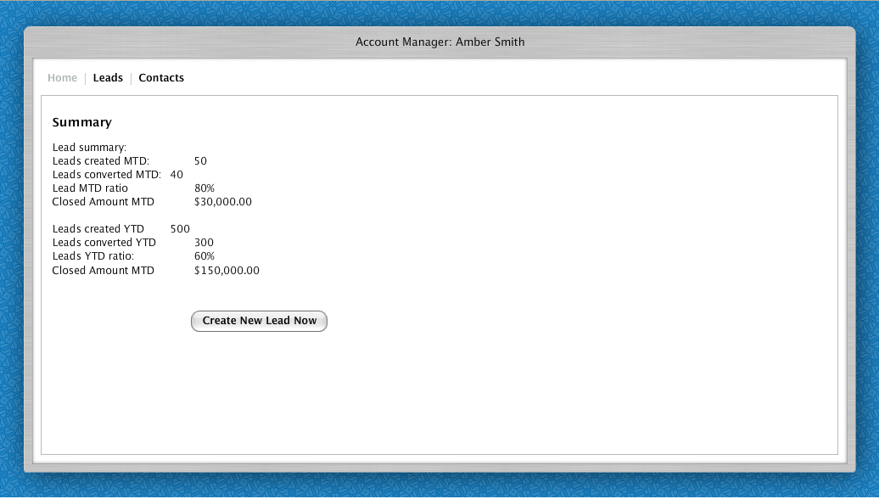
- Leads created Month to Date
- Leads converted to jobs Month to Date
- Percent of leads converted Month to Date
- Same thing for YTD ( year to date)

Review leads – Leads screen
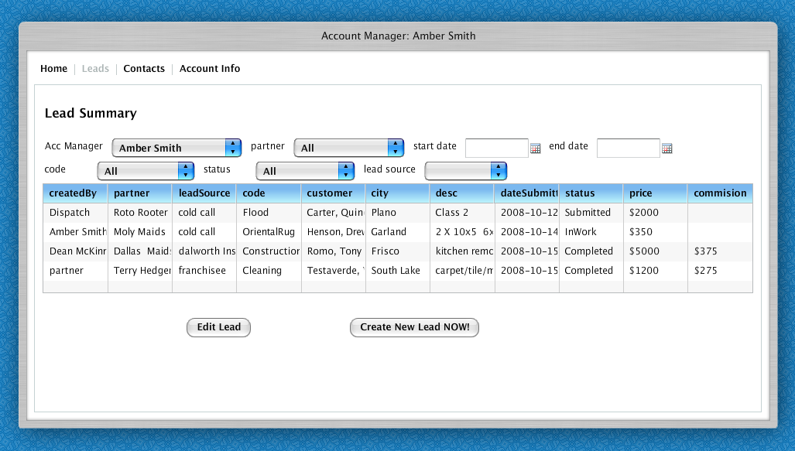
- System shows list of leads based on filters. Default last two weeks.
- Acc Manager may view leads created for other account managers to be able to answer questions from business partners. If account manager is changed, list of business partners also changing in partner drop down.
- Acc Manager must able to see how lead was created – by Acc Manager, by dispatch, by partner or by customer
- Acc Manager may filter by partner who created the lead, lead code , lead source, time frame based on date submitted.
- If lead in “Submitted” status, acc Manager must be able to edit lead “Edit Lead “ button

Create new lead

Business Rules
1. Account manager selects existing customer or creates new one
2. Any account manager can create a lead for customer who has direct account manager even if current account manager differs from customer’s account manager. Lead will have AM the same as customer’s AM. System should know who created a lead and who is a lead owner
3. Account manager can create a lead for customer who has no AM assigned without business partner participation
4. Any account manager can create a lead on behalf of any business partner (doesn’t matter which AM manages this business partner). If customer has direct AM – newly created lead belongs to business partner (not to AM)
5. When customer’s account manager is changed old leads created by another account manager should stay linked with old account manager
6. Dispatcher can see account manager’s leads and create new projects. Those leads has real customers so dispatch doesn’t have to use customer lookup
7. Account manager can see (without editing) other account manager’s leads as well as lead created by business partners (even if current AM doesn’t manage this business partner)
8. Account manager can set or unset business partner to existing lead.

Step 1
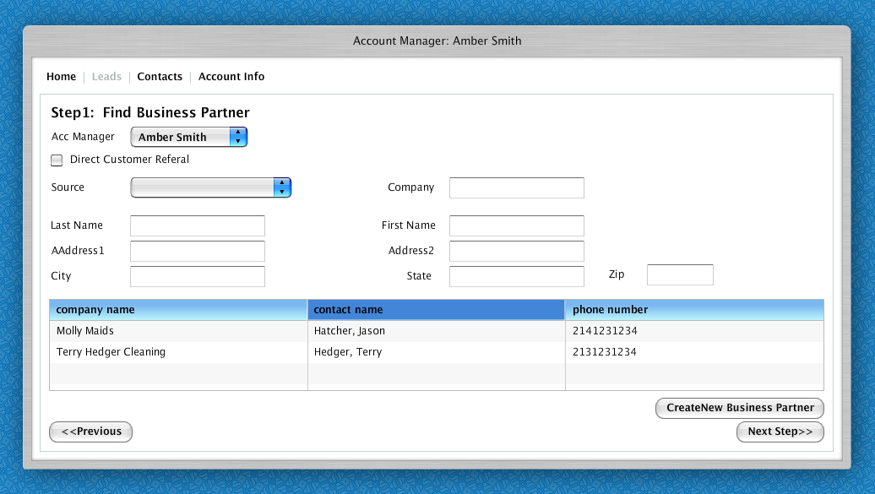

Create new Lead flow
- Acc Manager selects which account manager generated lead. By default system assumes it is this account manager. If account manager changes which account manager generated the lead, system shows list of business partners for the selected account manager
- Acc Manager selects if customer came from business partner of not (Direct Customer Referral)
  - If customer is direct, then go next step
- Acc Manager enters information about Business Partner and system trying to identity business partner by
  - Lead source
  - Company name
  - Last name of the contact
  - Fist Name of the contact
  - Company address
  - Phone number
  - Email.
- If business partner is found, then he is selected, otherwise Acc Manager may create new business partner

Step 2
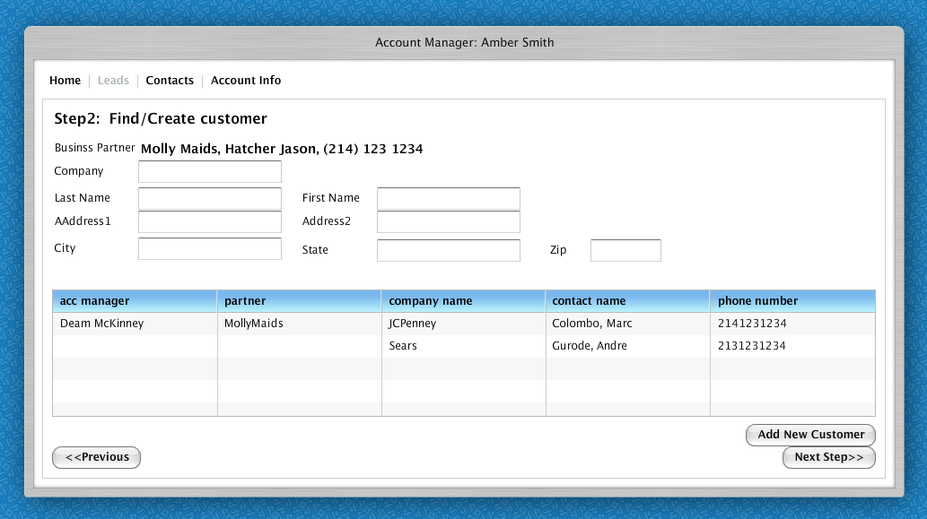
- System shows all customers associated with this business partner selected.
- Any account manager can create a lead for customer who has direct account manager even if current account manager differs from customer’s account manager. Lead will have AM the same as customer’s AM. System should know who created a lead and who is a lead owner
- Account manager can create a lead for customer who has no AM assigned without business partner participation
- 4. Any account manager can create a lead on behalf of any business partner (doesn’t matter which AM manages this business partner). If customer has direct AM – newly created lead belongs to business partner (not to AM)

- If Account manager cannot find customer , he types customer information and system trying to find customer and shows which acc manager and partner this customer belongs to. Account manager will create a lead for this customer and this partner will benefit from this lead, bu customer will continue to be assigned to previous business partner.
- Acc Manager is trying to find customer based on Company name, Last Name, First Name, address, city, state, zip
- If customer is not found, system creates customer

Step 3
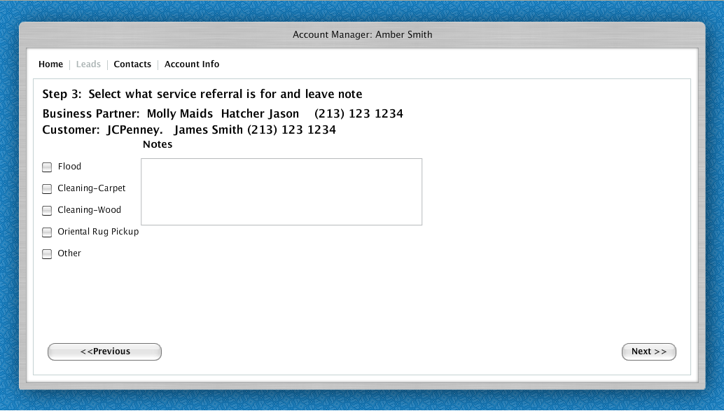
- Create referral
- System shows for which business partner and which customer
- System allows select type of service

Step4 Summary
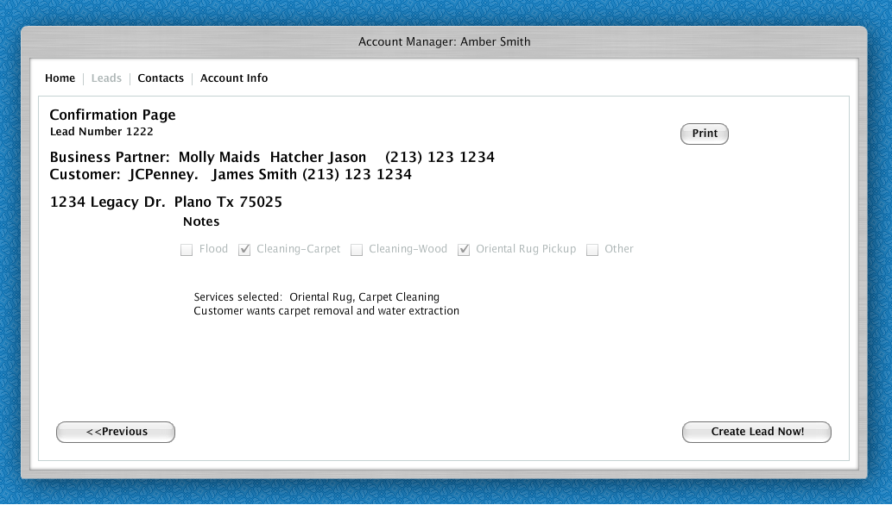
- System shows confirmation with the lead information
- Sales rep may print lead

Find customers and business partners
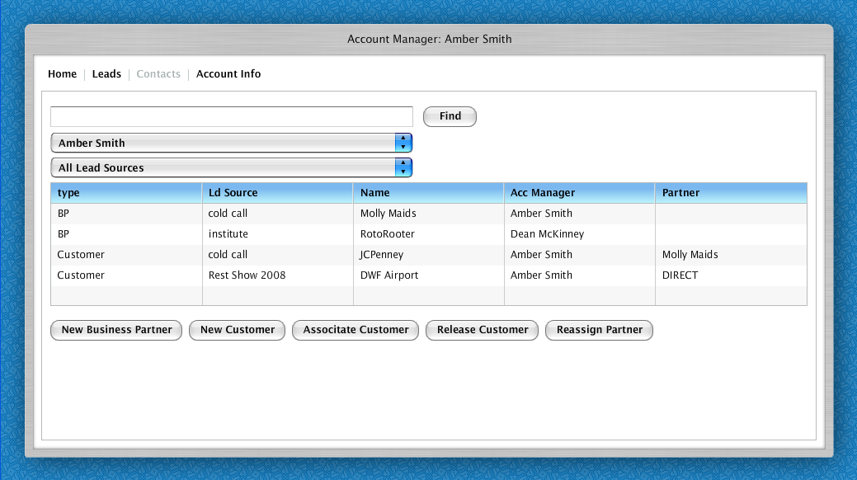
- Acc manager may find all customers and business partners.
- By default , system selects filter to look only in his customers and business partners.
- Acc Manager may create new customer and associate it with himself
- Acc Manger may create new business partner and associate it with himself
- Acc Manager may associate unassigned customers with himself
- Acc Manger may release his customer from association with himself
- If Acc Manager is Primary account manager, he may reassign business partner to another account manager

Manage Business Partners

Business Rules
- Each business partner is associated with one account manager
- Every business partner has account manager assigned
- Account manager can create new business partner
- Account manager can manage his business partners (change properties)
- By default account manager can see his business partners only. But he can see all of them also, answer any business partner questions (about leads etc), and create new leads. Primary Account Manager (PAM) can change business partner association to another account manager or to himself.

Flows
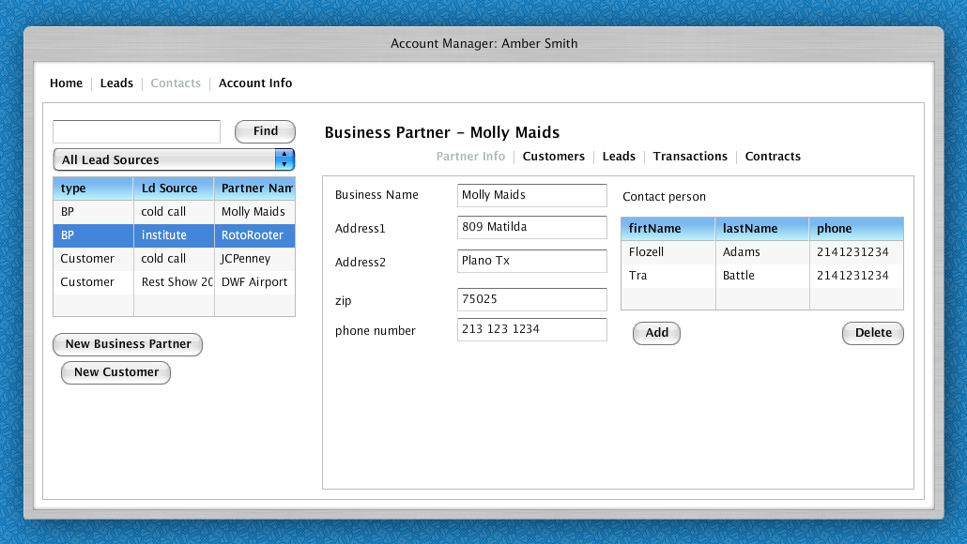
- Business partner has general info like
  - Business Name
  - Address1
  - Address2
  - City
  - State
  - Zip
  - Phone number
- Each business partner may have multiple contact people with different phone number and email addresses

Manage Customers

Business Rules:
- Account manager has an access to all the company’s customers. He can manage them, create new customers without creating a lead
- Account manager can associate himself with particular customer (business or residential) or destroy such association.
- Customer doesn’t have an association with business partner, except franchisee to exclusive customer (this association comes from servman and cannot be modified via website)

Flows
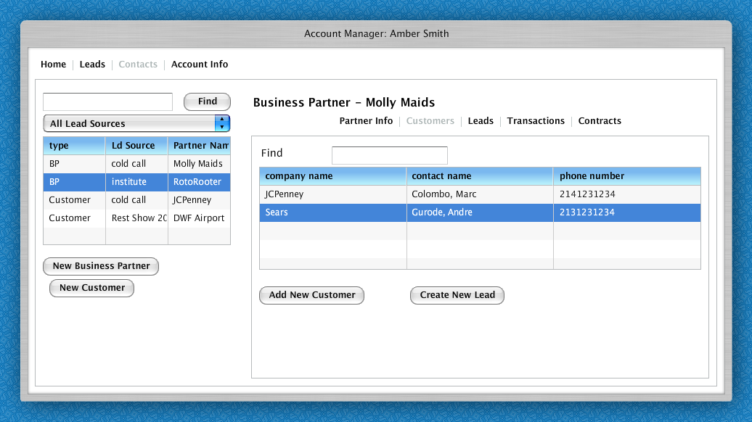
- Acc Manager must be able to see all the customers that this business partner generated
- Acc Manger may create new lead for this customer
- Acc Manager may see all leads generated for this customer by double clicking and going to customer info

Leads
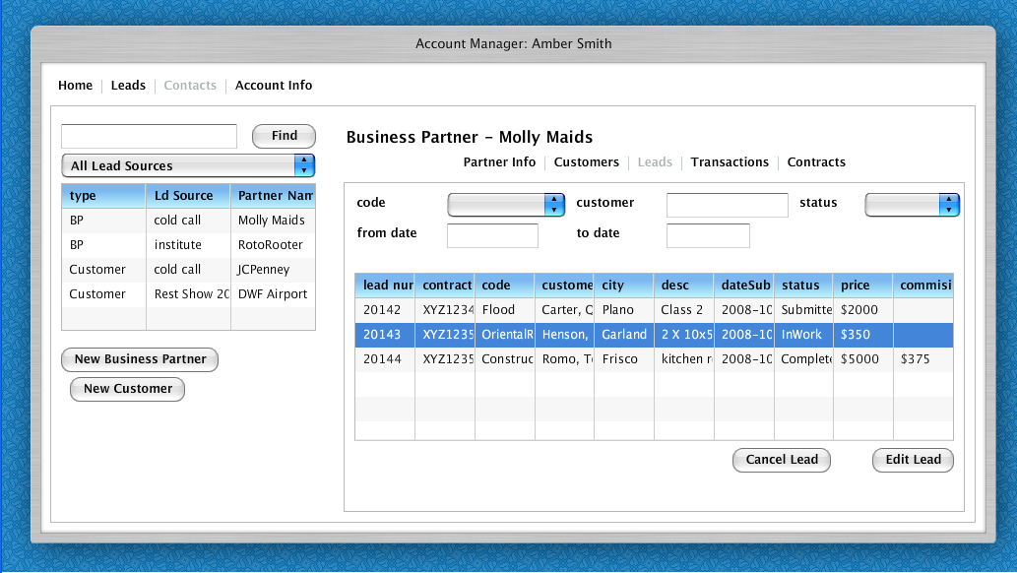
- Acct Manager must be able to review leads and lead statuses that business partner have submitted
  - Leads can be filtered by code, customer, status, from/to date
  - If lead is in completed status, commission amount is shown.
  - If lead is in status “Submitted” account manager must be able to edit lead or cancel lead.
  - If lead is cancelled, only status is changed and reason is specified. Lead information stays in the system.

Transactions
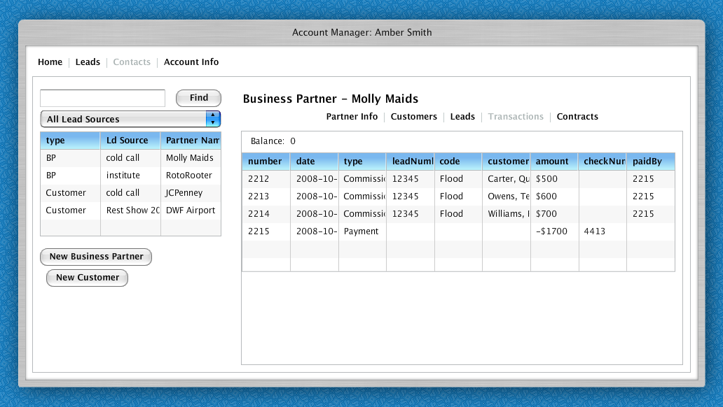
- Acc Manager must be able to see transactions
- Each transaction can be either debit (commission payment) or credit ( payment to from Dalworth to business partner)
- System must show balance. Balance reflect unpaid amount that business partners expect to collect from Dalworth

Manage Contracts

Business Rules
- Contracts define terms of agreement between business partner and Dalworth such as commissions
- Contract will have flat fee or percent of closed amount for each job type (Deflood, rug cleaning, miscellaneous)
- System will have default contract for the rest types of jobs which are not defined in typed contracts
- Contracts should be historical because they might change later. Commissions are calculated based on active contract rules. We need to be able to explain historical commission calculations based on historical contracts
- Insurance company adjustor cannot have commissioned contract for Deflood job types. He can have commission for the rest job types
- Dalworth franchisee must have extra contract of type “rug residual” to calculate residual Oriental rug commissions for exclusive customers where Franchisee did not generate a lead.

Flows

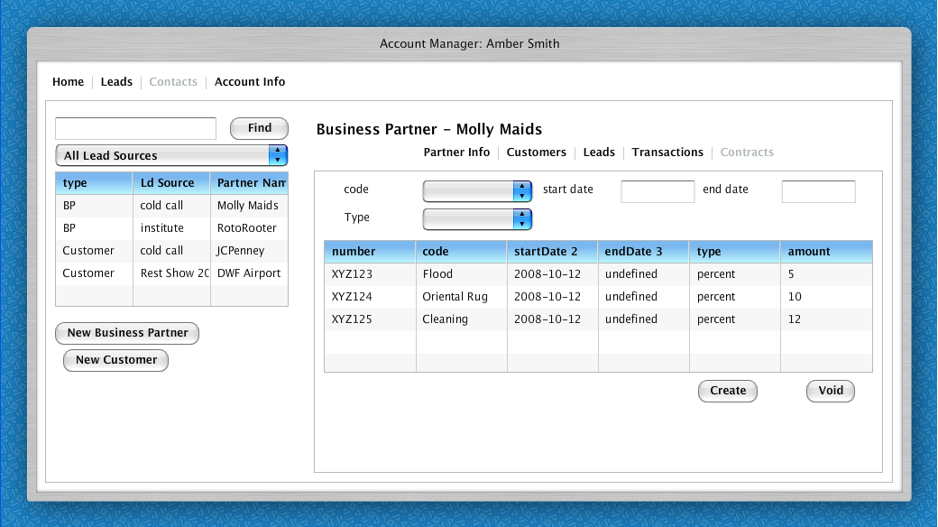
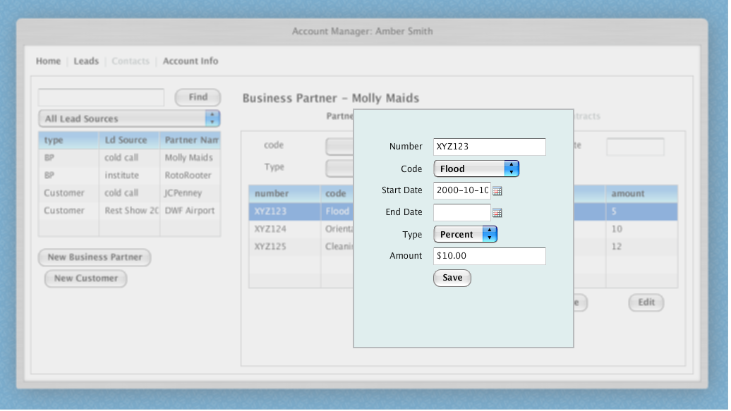
- Account manager may review and modify contracts
- Each contract has
  - Number – uniquely identify contract
  - Code – for which service contract is
  - Start Date – effective date
  - End date – date when it is expires. IF not specified, then it is current. Only one current contract can be per business partner for each code
  - Type – percent of closed amount or flat fee
  - Amount - percent or dollar amount.
- Account manager may void contract and will mark it as unusable.
- Account manager may create new contract by selecting “create”

Manage customer info

Acc Info
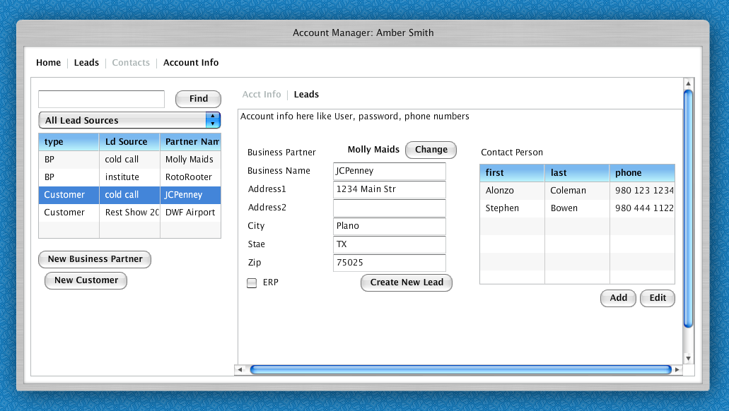
- Acc Manager selected customer
- If customer came as result of business partner, system shows from which business partner
- Acc Manager may modify this customer and assign it to another business partner
- The following fields are set
  - Business Partner
  - Address, City, State, zip
  - ERP – if customer has ERP (emergency R P some kind of contract)
- Acc Manager must be able to add new contact person
- Acc Manger must be able to edit contact person
- Acc Manager must be able to create new lead for this customer

Lead Info for this customer
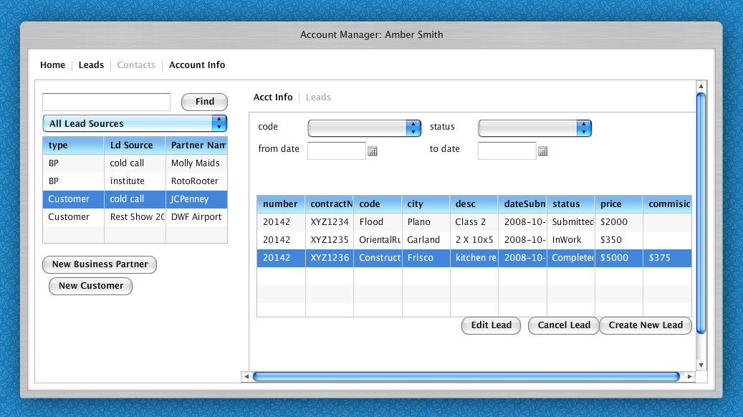
- Review all leads generated based on this customer
- Edit lead
- Cancel lead if lead in “Submitted” status
- Filter by code, status, date submitted

Company Owner
http://www.affilia.com/db/dalworth-leads/owner/company-owner.html

Login/Signup

Manage account managers (create , modify)

Review leads
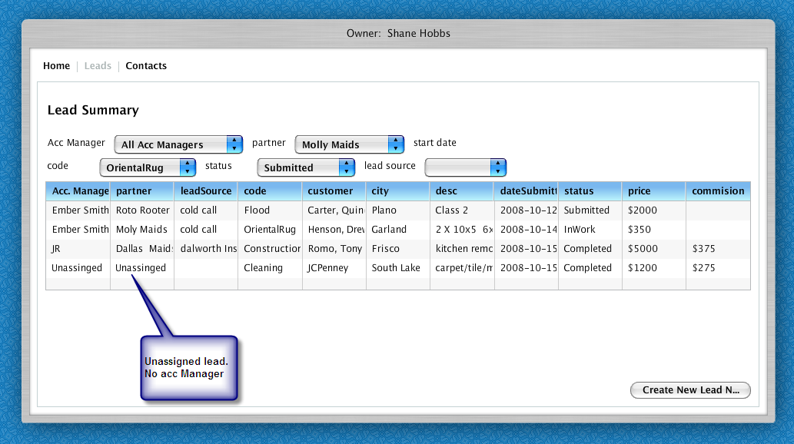
- Owner can see all leads sorted by acc manager, business partner

Review unassigned lead
- Owner must see leads (projects) that are commercial but not assigned to Acc Manager
- Owner must be able to select this customer and assign customer manager or ignore this customer
- Owner must be able to find customer already in the db and specify that this customer is already in the db.

Dalworth Institute Requirements
- Create classes
- View how many business partners signup
- Send notification to all partners that signup for a particular class

Manager contacts, create new lead
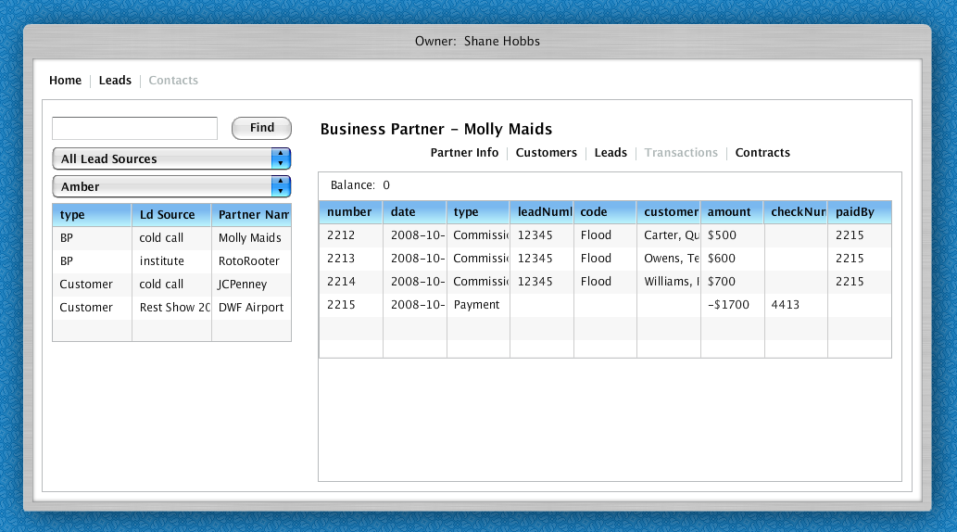
- Same functionality as account manager, however allows owner select by account manager.

Business Partner Requirements
http://www.affilia.com/db/dalworth-leads/business-partner/business-partner.html
- Register and setup profile
- Login, Password Retrieval
- Submit a lead to Dalworth for Flood , Construction, Rug Pickup, Rug Cleaning
- See his account manager information
- See status on of all leads

Create lead
- Business partner specifies existing customer (from subset of Dalworth customers) to create new lead (if another lead was created early for this customer)
- If this is a first lead – business partner specifies draft customer information (set of text fields). Draft customer is not visible in business partner customer list until customer becomes validated by dispatch and dalworth customer created

Project review

Business Requirements
- If business partner is ordinal BP (plumber etc.) he cannot review projects from his personal site – all the information he need to know could be obtained from leads
- If BP is insurance adjustor he can review all the projects related to him (not all the projects have a leads). Insurance adjustor should be able to get extended project information valuable for insurance company.
- If BP is Dalworth franchisee he’ll have projects w/o leads too (projects for exclusive customers w/o leads)
- BP can see project to lead connection (if exists) and project to debt transaction link.

FLOWS- TOD0:ADD

Update account info
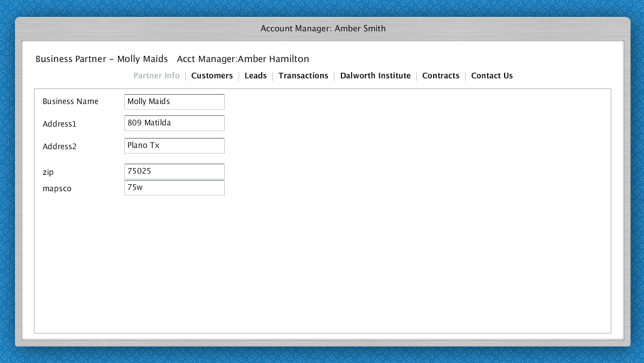
- Business partner can update his profile

Review customers submitted

Business Requirements
- Business partner can see only the small subset of Dalworth customers
- Business partner is able to access Dalworth customer once BP has created a lead for this customer and this lead became into real project
- Business partner cannot edit Dalworth customers

Flows
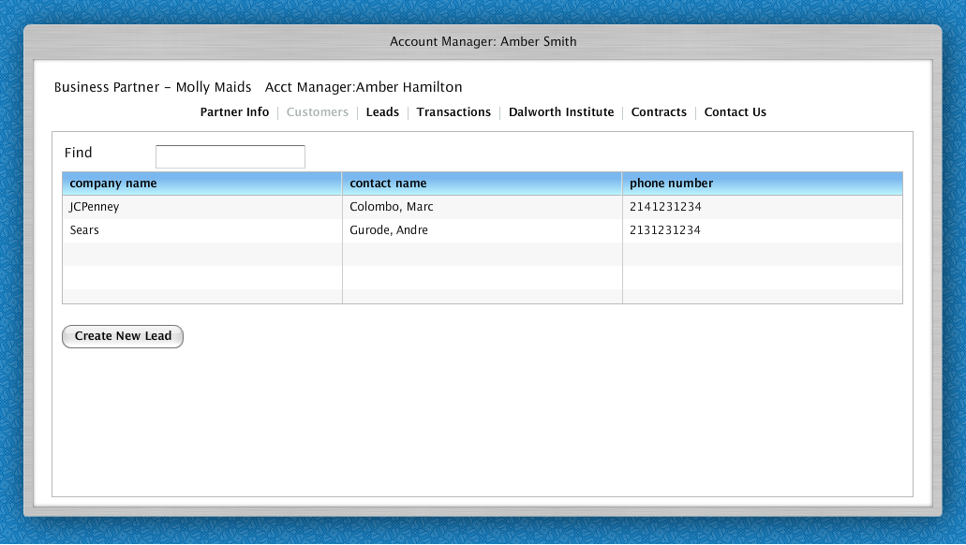
- Business partner can create new lead or find customer that he send leads for before and create lead for this customer

Lead Review
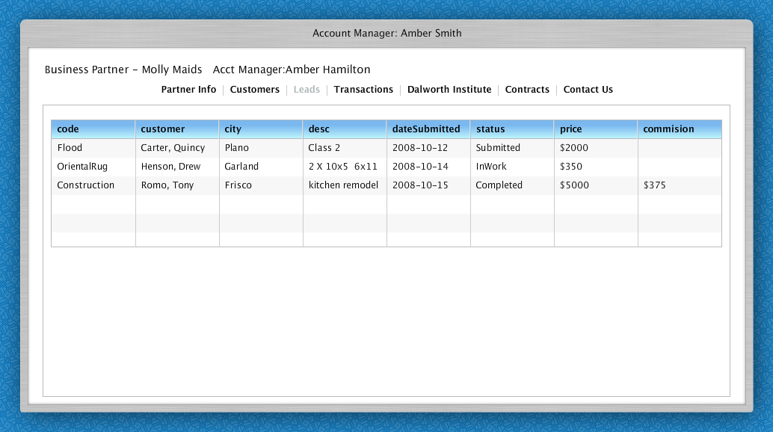
- Business Partner can review status of his submitted leads. Must be able to sort and filter.

Review Transactions and balance
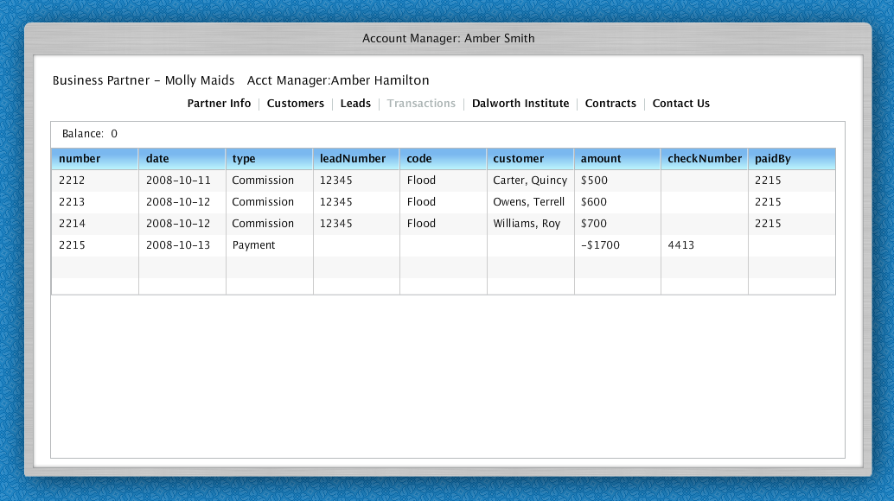
- Business partner must be able to review transactions

Review contracts
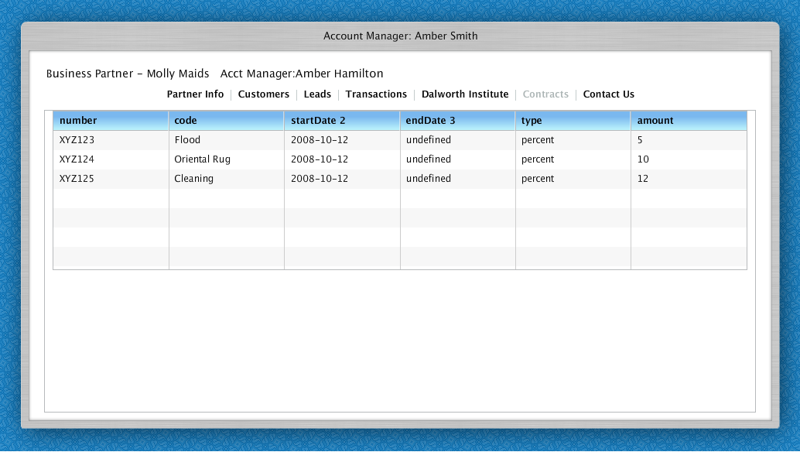
- Business partner can review contracts

Dalworth Institute Requirements
- See list of courses available
- See list of reservations
- Signup for course
- Cancel course reservation
- Print reservation and reservation cancellation

Dispatcher requirements
- Lead conversion
  - Dispatcher should process incoming leads from AM, BP or customer
  - To process lead dispatcher should validate job description, customer information
  - Dispatcher may call customer to validate information.
  - If lead has a real Dalworth customer dispatcher goes to visit creation bypassing customer lookup.
  - If lead contains draft customer information – system tries to populate customer lookup fields. Dispatcher edits those fields searching this customer and creates new one if not found.
  - Leads probably might have statuses like busy, left a message, call reschedule (need to figure it out)
- Create project without a lead
  - Dispatcher selects existing customer or creates new one
  - If customer indicates that he calls because account manager told him to:
    - If customer has an account manager assigned
      - Dispatcher indicates that customer’s account manager is a lead source
      - Dispatcher cannot specify any other account manager as a lead source
      - System creates lead for account manager
    - If customer does not have account manager assigned
      - Dispatcher may select any account manager
      - System creates lead for account manager
  - Dispatcher can specify Business Partner as a lead source. New lead will be generated.
    - Dispatcher may select Business Partner from the list of known business partners. Selected Business Partner will be the owner of the lead
    - Dispatcher may enter business partner as text indicating that business partner is not in the list of partners available. Generated lead will have no owner. AM should review this lead and set correct BP or create one if not exists
  - Dispatcher can mark project with high value flag (customer is high value, so need attention by account manager) which will mark this project out in AM’s projects screen. All the business customers should have this flag set unless customer is marked as unimportant.
  - If customer is exclusive to franchisee, project becomes related to this franchisee (without a lead). If dispatcher has specified franchisee as lead source new lead will be generated (even when customer is not exclusive).
  - Dispatcher should specify insurance company and insurance adjustor if known. This information should be set once insurance adjustor for this project is known. Not all the insurance adjustors will have web site account, so dispatch can specify name as entity or text. Lead won’t be generated but project becomes related to adjustor.
  - Dispatcher should be able to specify insurance adjustor as lead source. In this case lead will be generated
  - Account manager can make a modification and unset high importance flag. All future orders for this customer will not require attention of account manager.

Bookkeeper requirements

Post transaction
- Find business partner
- Post transaction to this business partner
  - Transaction number
  - Transaction type (check)
  - Check number
  - Amount
  - Date

Void transaction
- Find business partner
- Find credit transaction (payment)
- Make transaction as void
- System must reflect the balance based on the fact that transaction is void.
  - Date voided

Administrator
- Login, password reminder
- Create classes

Customer portal (should be integrated with Dalworth.com)
Provides a place where end customers or Carpet Cleaning and Restoration can create a lead for rug pickup, carpet cleaning, flood and have ability to be notified on job progress (scheduled, rejected, completed).

Customer requirements
- Register, setup profile
- Login, password reminder
- Create a lead for carpet cleaning, flood, rug pickup
- See history of jobs completed by Dalworth
- Notified when status of the lead or project changed
  - Pending – lead is still not processed
  - Converted to Project – project is created
  - Scheduled – scheduled for execution
  - In Process – in process of being completed
  - Completed – job is completed
  - Canceled – job was cancelled

Dispatcher requirements
- Reviews leads
- Arranges visits
- Creates projects and dispatches jobs

Company owner requirement
View list of leads generated from the web
See project status

